Requirements:

* Salesforce user should be able to UPLOAD files (.xls, .doc, .xlsx only)
* User should be able to DOWNLOAD files
* User should be able to EDIT file name and description
* Files are GROUPED under its Sections
* Component can be RE-USED to cater to different sections

Here is a screenshot how the UI should be.

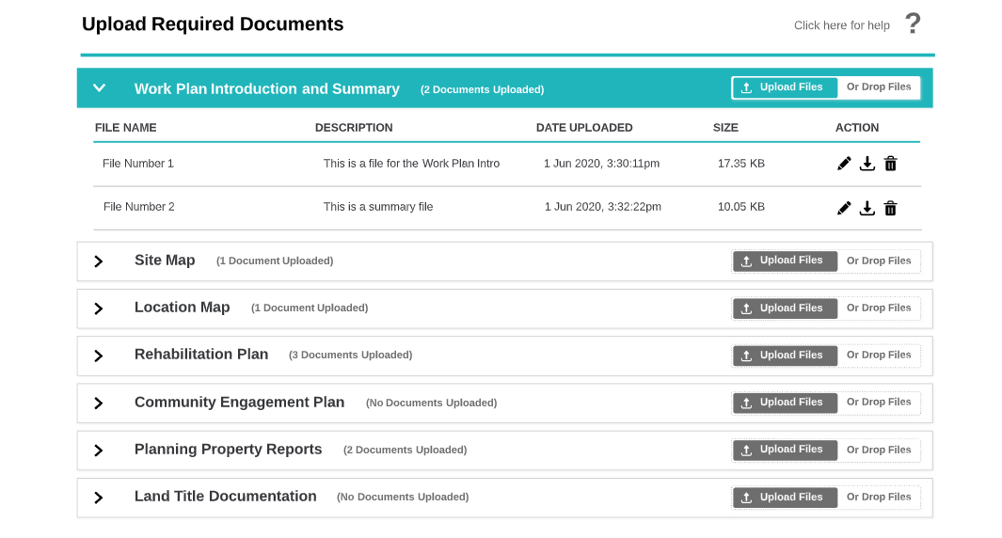

Expectation:

* A document, no more than 2 pages, explaining the approach/solution.
* A working solution or skeleton of the approach.
* Good test coverage for the apex code.

Note:

* You can use Aura or LWC
* We are not particular about the colours used.
* Once you are complete with the challenge, upload the code on GitHub and send a note to bharath.kumar@ecodev.vic.gov.au

**Solution:**

* The project has two aura components:

1. ClientFileSummaryCmp :
   1. This is a parent Component with a search box to search account record and it’s related files by **name**(either first/last name)). This parent component displays the list of related files in separate sections grouped by category.
2. FilesDataTableCmp :
   1. This is the child component which receives the list of files table data, account id and category from parent component during initial load. Upon update/delete/upload in table data the component performs necessary action and re-renders the new data for the table.
   2. The table columns Title and Description support inline edit.
   3. The Createddate is formatted to replicate above screenshot on client side.
   4. The ContentSize has been formatted to replicate above screenshot on client side.

* I have used one single apex class controller and test class for handling the server-side logic using wrapper class.
  + ClientFileSummaryController
  + ClientFileSummaryControllerTest